Protein-macromolecule interactions pH dependence and machine learning
25926 group discussion M1 Shunya Sudo
Research Objectives
My research goal is to discover polymers that boost heat resistance without compromising activity for three enzymes: horseradish peroxidase, glucose oxidase, and lipase. I focus on three monomer types—zwitterionic, cationic, and hydrophobic—and apply Bayesian optimization to efficiently find the best composition ratios with minimal experiments. We start with MPC as the zwitterionic monomer, MTAC as the cationic monomer, and BMA as the hydrophobic monomer. Once we determine the optimal MPC/MTAC/BMA ratio, we will explore other hydrophobic units—EHMA, LMA, and MPTSSi—to identify the most effective hydrophobic component.

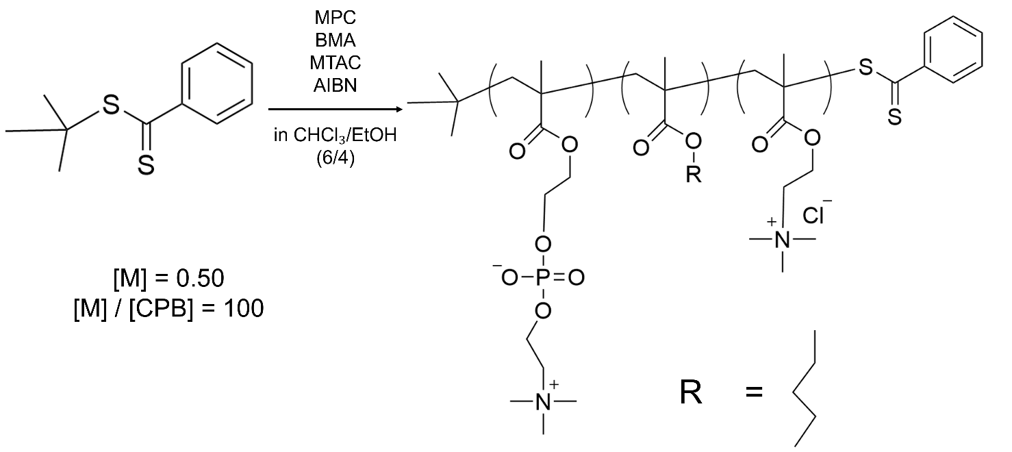

 | Feed Ratio (mol %) |  |  | Composition Ratio (mol %)
Polymer | MPC | BMA | MTAC | MPC | BMA | MTAC
PMBTA-1 | 80 | 4 | 16 | 84.4 | 2.5 | 13.1
PMBTA-2 | 80 | 16 | 4 | 78.6 | 15.9 | 5.5
PMBTA-3 | 30 | 14 | 56 | 30.4 | 14.2 | 55.4
PMBTA-4 | 30 | 56 | 14 | 32.7 | 33.2 | 34.1
PMBTA-5 | 55 | 22.5 | 22.5 | 50.3 | 22.4 | 22.4

Summary of this report
・Aggregation state of copolymer and enzyme when dissolved in EtOH
・Enhancement of lipase thermal stability by copolymer PMBTA
・Enhancement of GOx thermal stability by copolymer PMBTA

- Measurement of particle size distribution (PMBTA)
The polymer was dissolved in ethanol, and then the particle size distribution was measured.

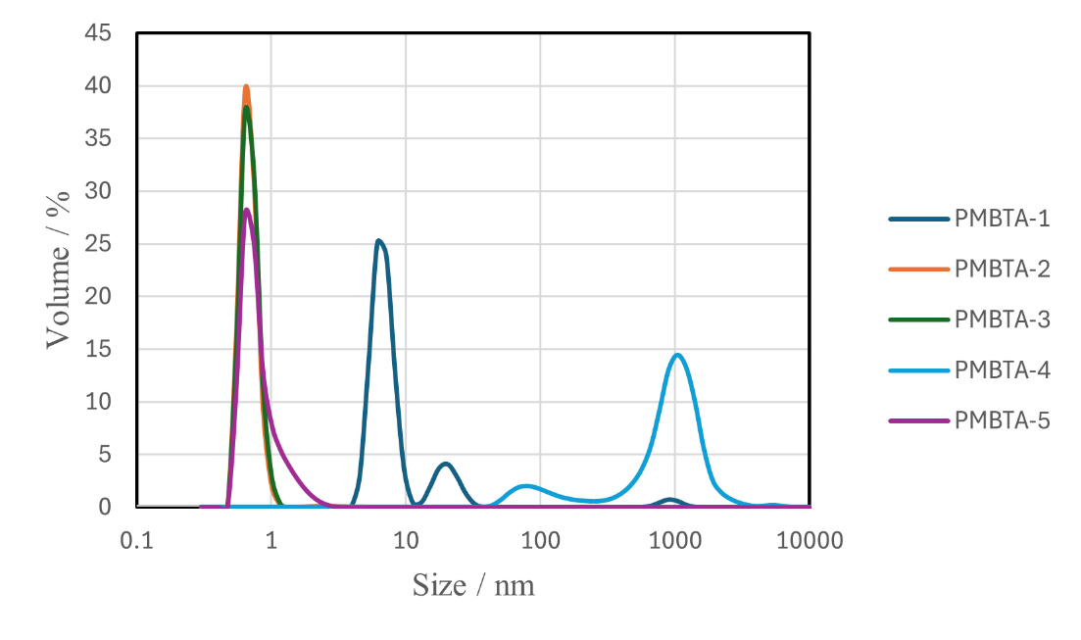
Figure 1. Particle size distribution of PMBTA with 1% EtOH (2025/8).
  - Experimental Methods
- The copolymers PMBTA-1~5 were dissolved in EtOH to prepare a 50 mg/mL polymer stock solution.
- 10 μL of (1) was added to 990 μL of water.
- 780 μL of (2) was used for measurement.

1.2 Particle size distribution
Particle size distribution was measured for each of PMBTA-1-5.

Table 1. Particle size distribution of PMBTA
Copolymer | volume average diameter (Z-avg) (nm) | center diameter D50 (nm)
PMBTA-1 | 19.9 | 11.9
PMBTA-2 | 1.35 | 0.98
PMBTA-3 | 0.728 | 0.629
PMBTA-4 | 654 | 658
PMBTA-5 | 0.866 | 0.612
- The PMBTA copolymer dissolved in EtOH, and a 50 mg/mL EtOH solution became colorless and transparent.
- It is thought that the copolymer could be dissolved by dissolving it completely in EtOH.
- PMBTA-4 was particularly difficult to dissolve in ethanol and had a larger particle size.

- Measurement of zeta potential (PMBTA)
After dissolving PMBTA in ethanol, the zeta potential was measured.

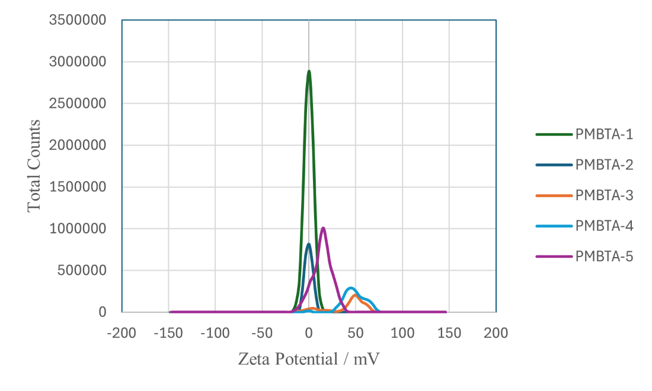
Figure 2. Zeta potential of PMBTA with 1% EtOH (2025/8).
2.1 Zeta potential
Measured simultaneously with the same solution as particle size distribution.
Table 2. Zeta potential of PMBTA
Copolymer | Average ζ (weighted mean) | D₅₀ (50 %)
PMBTA-1 | -0.161 | -2.57
PMBTA-2 | -0.144 | -2.77
PMBTA-3 | 40.9 | 46.1
PMBTA-4 | 48.1 | 45.8
PMBTA-5 | 14.2 | 12.4
- As the MTAC concentration increases, the zeta potential also increases, suggesting the data is valid.
- 1% EtOH is considered to have no effect on the zeta potential.

- Measurement of particle size distribution (Lip, GOx)
The particle size distribution of enzymes dissolved in ethanol was examined. The particle size distributions of lipase and GOx were measured.

  - Experimental Methods
Lip-1%EtOH-indirect (The enzyme does not come into contact with pure ethanol.)
- Weighed 1.0 mg of lipase (GOx) (and sequentially added water and EtOH to achieve an enzyme concentration of 0.5 mg/mL).
- Added 1980 μL of water (0.1 mol/L phosphate buffer solution, pH 7.0 for GOx).
- Added 20 μL of EtOH.

Lip (GOx)-1%EtOH-direct (Enzymes come into contact with pure ethanol)
- Lipase (GOx) was dissolved in EtOH to prepare a 50 mg/mL solution.
- Add 10 μL of solution (1) to 990 μL of water (0.1 mol/L phosphate buffer solution, pH 7.0 for GOx).

Lip-water, GOx-water
Dissolve Lip (GOx) in water (0.1 mol/L phosphate buffer solution, pH 7.0 for GOx) to prepare a 0.5 mg/mL solution.

3.2 Particle size distribution
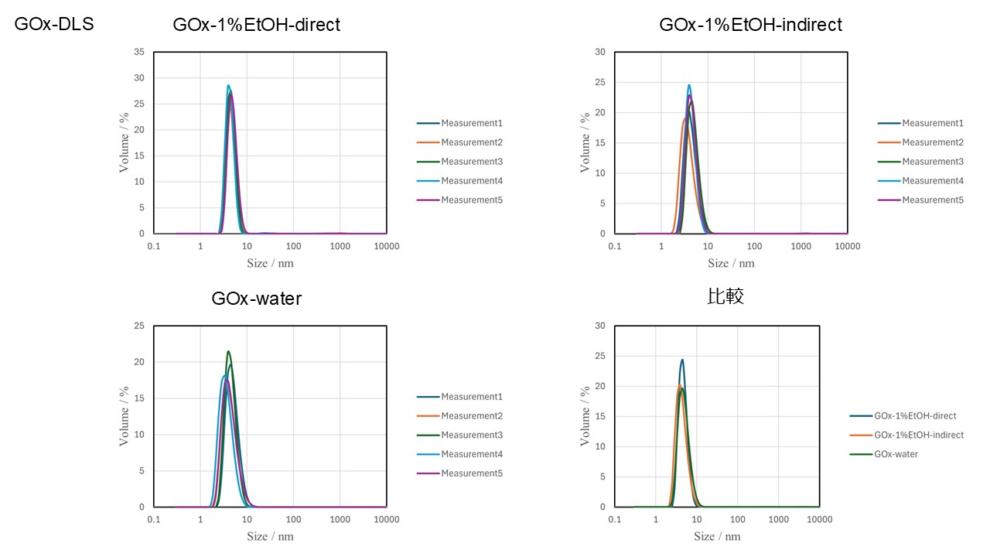
Figure 3. Particle size distribution of GOx.
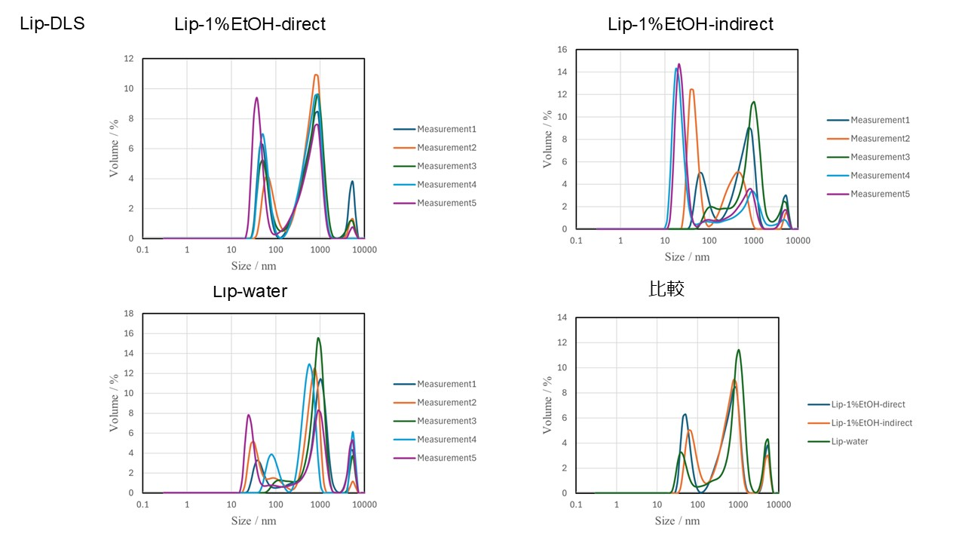
Figure 4. Particle size distribution of Lip.
- GOx did not affect the particle size distribution with or without 1% EtOH.
- Lip had larger particle sizes and less clean data, but was unaffected by EtOH.

- Measurement of zeta potential (Lip, GOx)
Measured the zeta potential using the solution employed for particle size distribution.
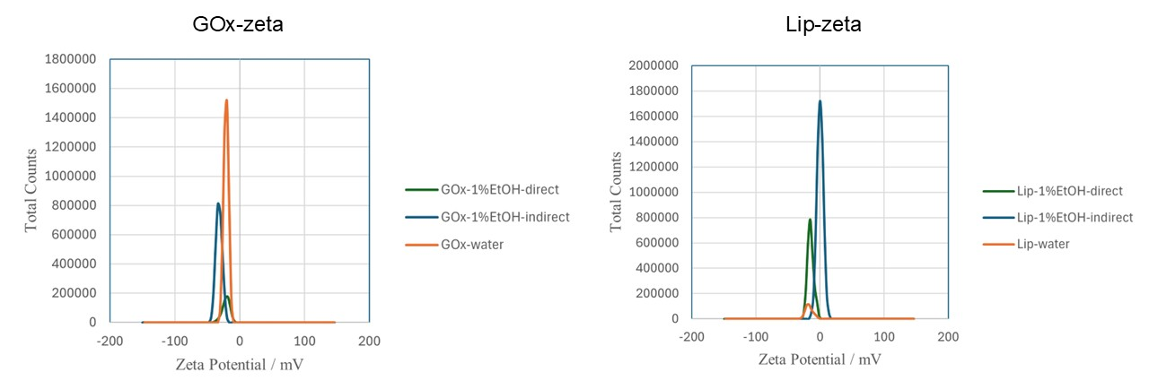
Figure 5. Zeta potential of GOx and Lip.

- The presence of 1% EtOH did not significantly alter the zeta potential.
- It is considered that the enzyme structure remains unchanged even upon contact with 1% EtOH.

- Enzyme activity with EtOH (Lip)
The effect of 1% ethanol on the heat tolerance of Lip was investigated.
  - Experimental Methods
- Dissolve Lip in buffer (water/0.1 mol/L phosphate buffer solution, pH 7.0 = 50/50) and prepare a 0.05 mg/mL solution.
- Aliquoted into 1 mL tubes and heated in a thermoshaker. (60°C: 0 min, 5 min, 10 min, 15 min, 20 min, 40 min, 60 min)
- Prepared the substrate solution.
  - p-Nitrophenyl Palmitate was dissolved in 2-propanol.
  - Buffer was added to prepare a solution at 0.2 mg/mL, with a buffer/2-propanol ratio of 9:1.
  - Sodium Deoxycholate was added to a concentration of 5 mM to prevent the substrate solution from turning yellow.
- Data was collected using a plate reader, and the slope obtained by fitting the initial velocity of the assay was defined as the enzyme activity (interval: 5s, repeat: 20 times).
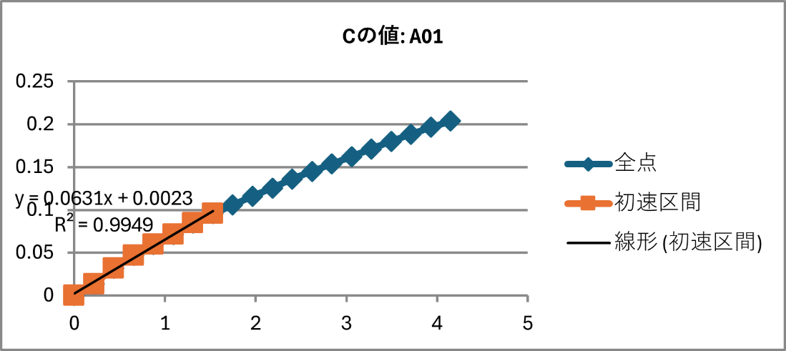
  - Lip assay
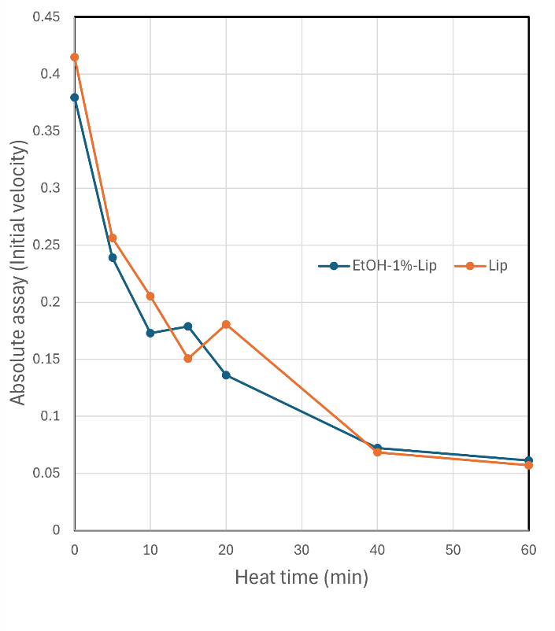
Figure 6. shows the absolute activity of the Lip assay under 1% EtOH conditions and under buffer-only conditions.
There was no significant change in activity with or without EtOH. It was found that EtOH at approximately 1% does not inhibit Lip activity.

REA (Retain Enzyme Activity) was calculated from the absolute activity at 0 minutes and the absolute activity at each heating time point.
The REA when heated for n minutes is
$$REA= \frac{n\min{Activation}}{Unheated Activation} ×100 (\%)$$

Figure 6. Lip assay with or without EtOH (Absolute activity)
Table 3. REA of Lip (%)
 |  | Heat time (min)
 |  | 0 | 5 | 10 | 15 | 20 | 40 | 60
REA (%) | 1%EtOH-Lip | 100 | 63 | 46 | 47 | 35 | 19 | 16
REA (%) | Lip | 100 | 62 | 49 | 36 | 43 | 16 | 14

- Enzyme activity with EtOH (Lip, PMBTA)
Investigated the heat tolerance of PMBTA when dissolved in EtOH and heated together with Lip.

  - Experimental Methods
- Dissolve Lip in buffer (water/0.1 mol/L phosphate buffer solution, pH 7.0 = 50/50) and prepare a 0.05 mg/mL solution.
- Dissolve PMBTA in EtOH to a concentration of 150 mg/mL.
- Mix 2.97 mL of (1) with 30 μL of (2).
- Aliquot into 1 mL tubes and heat in a thermoshaker. (60°C: 0 min, 5 min, 10 min, 15 min, 20 min, 40 min, 60 min)
- Prepare the substrate solution.
  - p-Nitrophenyl Palmitate was dissolved in 2-propanol.
  - Buffer was added to prepare a solution at 0.2 mg/mL, with a buffer/2-propanol ratio of 9:1.
  - Sodium Deoxycholate was added to a concentration of 5 mM to prevent the substrate solution from turning yellow.
- Data was collected using a plate reader, and the slope obtained by fitting the initial velocity of the assay was defined as the enzyme activity (interval: 5s, repeat: 20 times).

  - Lip assay with PMBTA
Lip was heated together with PMBTA-4, and its activity was then measured.
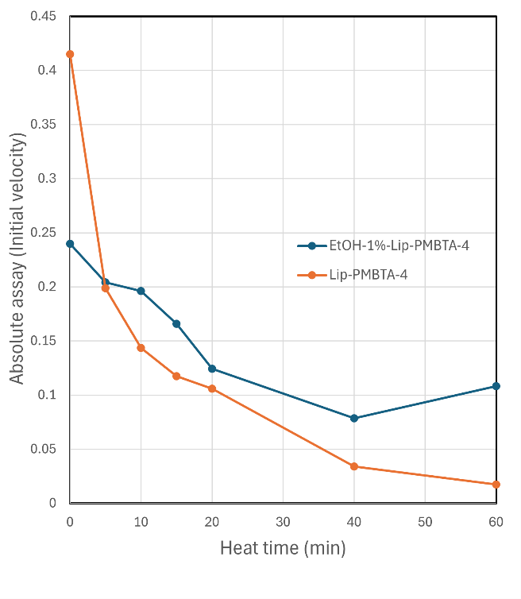
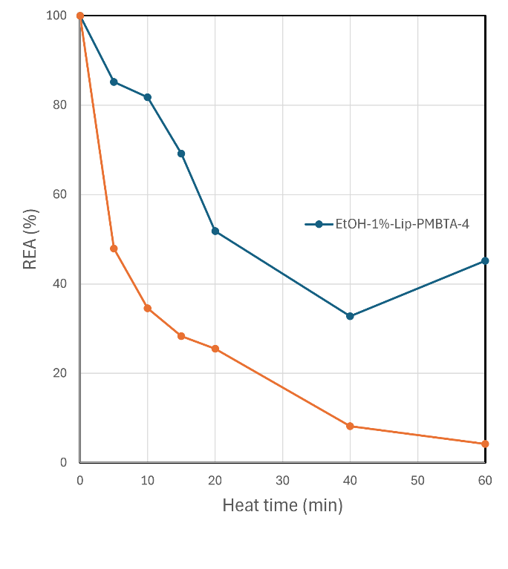
Figure 7. Lip assay with PMBTA-4 (left: Absolute activity, right: REA)
Table 4. REA of Lip with PMBTA-4 (%)
 |  | Heat time (min)
 |  | 0 | 5 | 10 | 15 | 20 | 40 | 60
REA (%) | 1%EtOH-Lip with PMBTA-4 | 100 | 85 | 82 | 69 | 52 | 33 | 45
REA (%) | Lip with PMBTA-4 | 100 | 48 | 34 | 28 | 25 | 8.1 | 4.2

Dissolving PMBTA completely in pure EtOH, dissolving the polymer, then mixing it with the enzyme and heating it is considered effective for improving heat resistance (a similar trend was observed with other PMBTA).
Next, the polymer was dissolved in EtOH, then mixed with the Lip solution and heated.

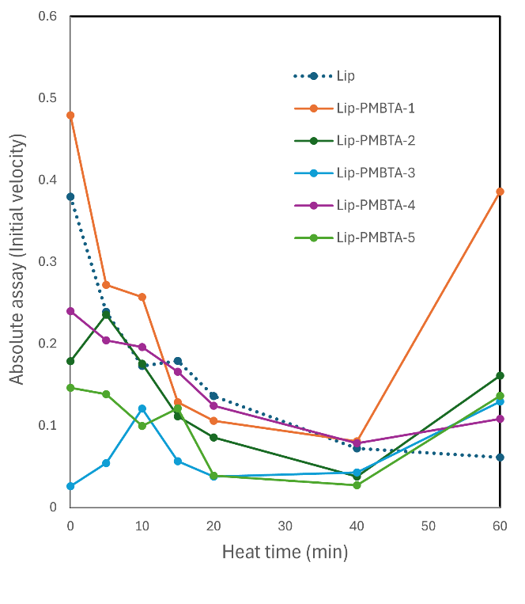
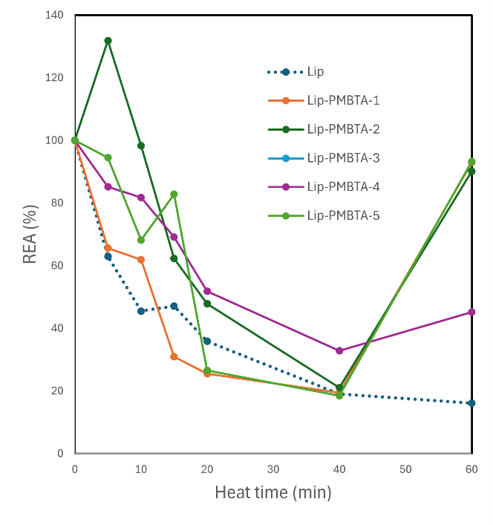

Figure 8. Lip assay with PMBTA in 1% EtOH environment (left: Absolute activity, right: REA)
Table 5. REA of Lip with PMBTA (%)
 |  | Heat time (min)
 |  | 0 | 5 | 10 | 15 | 20 | 40 | 60
REA (%) | Lip | 100 | 63 | 46 | 47 | 36 | 19 | 16
REA (%) | Lip with PMBTA-1 | 100 | 57 | 53 | 27 | 22 | 17 | 81
REA (%) | Lip with PMBTA-2 | 100 | 132 | 98 | 62 | 48 | 21 | 90
REA (%) | Lip with PMBTA-3 | 100 | 207 | 463 | 217 | 144 | 163 | 495
REA (%) | Lip with PMBTA-4 | 100 | 85 | 82 | 69 | 52 | 33 | 45
REA (%) | Lip with PMBTA-5 | 100 | 95 | 68 | 83 | 27 | 18 | 93

- Regarding PMBTA-3, its absolute activity is also significantly low, and heating causes irregular changes in REA, making this a point requiring discussion.
- For the 60-minute heating condition, measurement was performed immediately after heating, likely resulting in higher solution temperature and increased activity.
- The points marked in yellow are those where higher REA values were recorded compared to the Neutral Lip REA at the same heating time.

- Concentration adjustment for GOx activity
The concentration was prepared to measure GOx activity. To facilitate comparison when adding the polymer, a sample was selected that retains 20% residual activity after 40 minutes of heating in a neutral state.
  - Experimental Methods
- GOx was dissolved and prepared at three concentrations: 0.0016 mg/mL, 0.0008 mg/mL, and 0.0004 mg/mL in 0.1 mol/L phosphate buffer solution, pH 7.0.
- The solutions were aliquoted into 1 mL tubes and heated in a thermoshaker. (60°C: 0 min, 5 min, 10 min, 15 min, 20 min, 40 min, 60 min)
- Preparation of the substrate solution
  - HRP was dissolved at 1 mg/mL in 0.1 mol/L phosphate buffer solution, pH 7.0, to prepare the HRP solution.
  - Glucose was dissolved at 1.8 mg/mL in 0.1 mol/L phosphate buffer solution, pH 7.0, to prepare the glucose solution.
  - Prepare a 10 mL substrate solution by adding 50 μL of HRP solution, 5 mL of glucose solution, 50 μL of Amplex Red, and 4.95 mL of pH 7.0 PBS.
- Data was collected using a plate reader, and the slope obtained by fitting the initial velocity of the assay was defined as the enzyme activity (interval: 10 seconds, repeat: 60 times).
- An appropriate concentration was selected as the initial activity.

  - Result
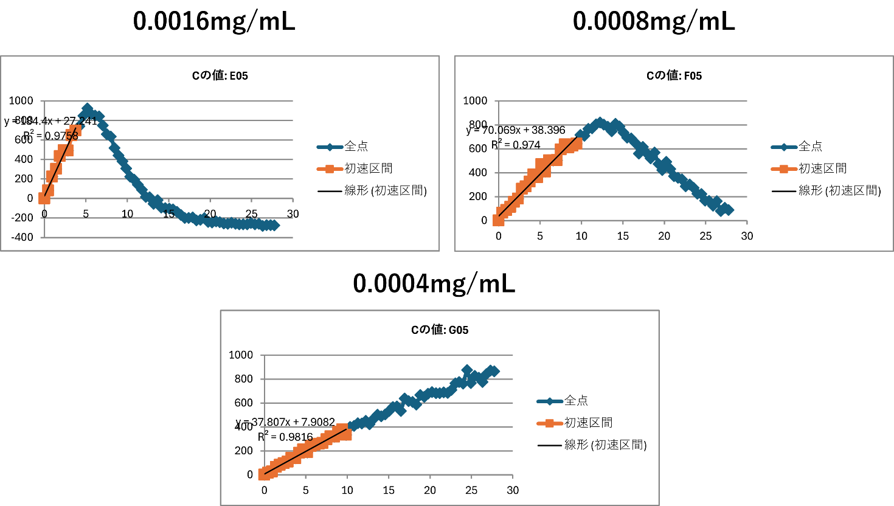
Figure 10. GOx assay of 0.0016, 0.0008, 0.0004mg/mL (heat time 40 min).
Table 6. REA of GOx (Concentration adjustment)
 |  | Heat time (min)
 |  | 0 | 5 | 10 | 15 | 20 | 40 | 60
GOx Concentration | 0.0016 mg/mL | 100 | 93 | 83 | 60 | 54 | 27 | 0.8
GOx Concentration | 0.0008 mg/mL | 100 | 82 | 72 | 65 | 36 | 22 | 1.5
GOx Concentration | 0.0008 mg/mL | 100 | 88 | 61 | 29 | 43 | 27 | 3

- REA decreased to 20-30% after approximately 40 minutes of heating at all concentrations.
- Selected 0.0016 mg/mL, where the reduction in absolute activity was overwhelmingly large.
- Since initial activity can be observed at the point of initial velocity, the plate reader interval can be shortened.

- Enzyme activity with EtOH (GOx, PMBTA)
PMBTA was dissolved in EtOH and then added to the GOx solution to measure its thermal stability.

  - Experimental Methods
- Dissolve GOx in 0.1 mol/L phosphate buffer solution, pH 7.0, and prepare a solution at 0.0016 mg/mL.
- Dissolve PMBTA in EtOH and prepare a solution at 4 mg/mL.
- Mix 990 μL of (1) with 10 μL of (2).
- Heat using a thermoshaker. (60°C: 0 min, 5 min, 10 min, 15 min, 20 min, 40 min, 60 min)
- Prepare the substrate solution.
  - HRP was dissolved at 1 mg/mL in 0.1 mol/L phosphate buffer solution, pH 7.0, to prepare the HRP solution.
  - Glucose was dissolved at 1.8 mg/mL in 0.1 mol/L phosphate buffer solution, pH 7.0, to prepare the glucose solution.
  - Prepare a 10 mL substrate solution by adding 50 μL of HRP solution, 5 mL of glucose solution, 50 μL of Amplex Red, and 4.95 mL of pH 7.0 PBS.
- Data was collected using a plate reader, and the slope obtained by fitting the initial velocity of the assay was defined as the enzyme activity (interval: 5s, repeat: 30 times).
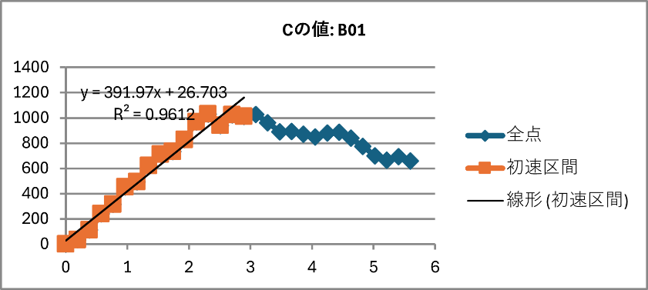

  - GOx assay with PMBTA
GOx was mixed with PMBTA, heated, and then its activity was measured using a plate reader.

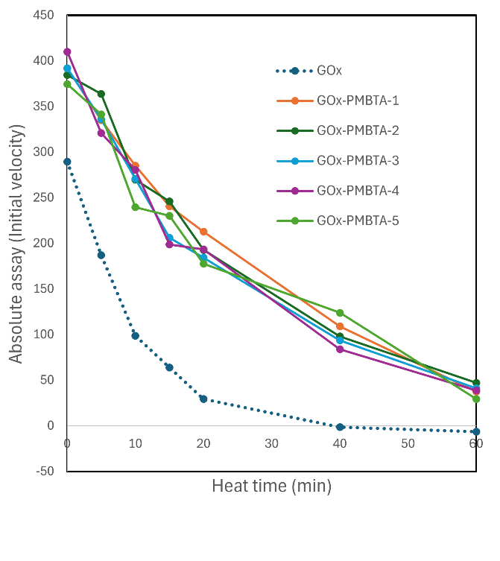
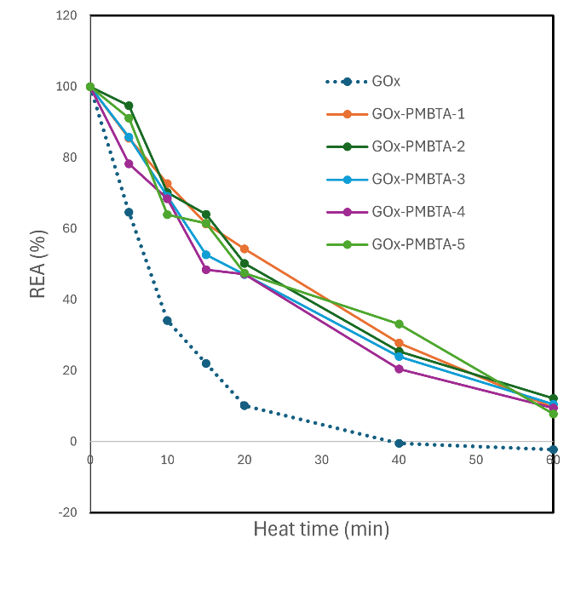

Figure 11. GOx assay with PMBTA in 1% EtOH environment (left: Absolute activity, right: REA)

Table 7. REA of GOx with PMBTA (%)
 |  | Heat time (min)
 |  | 0 | 5 | 10 | 15 | 20 | 40 | 60
REA (%) | GOx | 100 | 65 | 34 | 22 | 10 | 0 | 0
REA (%) | GOx with PMBTA-1 | 100 | 85 | 73 | 61 | 54 | 28 | 9.5
REA (%) | GOx with PMBTA-2 | 100 | 95 | 70 | 64 | 50 | 25 | 12
REA (%) | GOx with PMBTA-3 | 100 | 86 | 69 | 53 | 47 | 24 | 11
REA (%) | GOx with PMBTA-4 | 100 | 78 | 68 | 48 | 47 | 20 | 9.4
REA (%) | GOx with PMBTA-5 | 100 | 91 | 64 | 61 | 47 | 33 | 7.8

- For all heating times, results exceeding the REA of neutral GOx were achieved in the PMBTA.
- The low absolute activity of neutral GOx requires discussion.

- Bayesian optimization for GOx
Using Bayesian optimization on the existing data for GOx, we generated candidate compounds for synthesis.
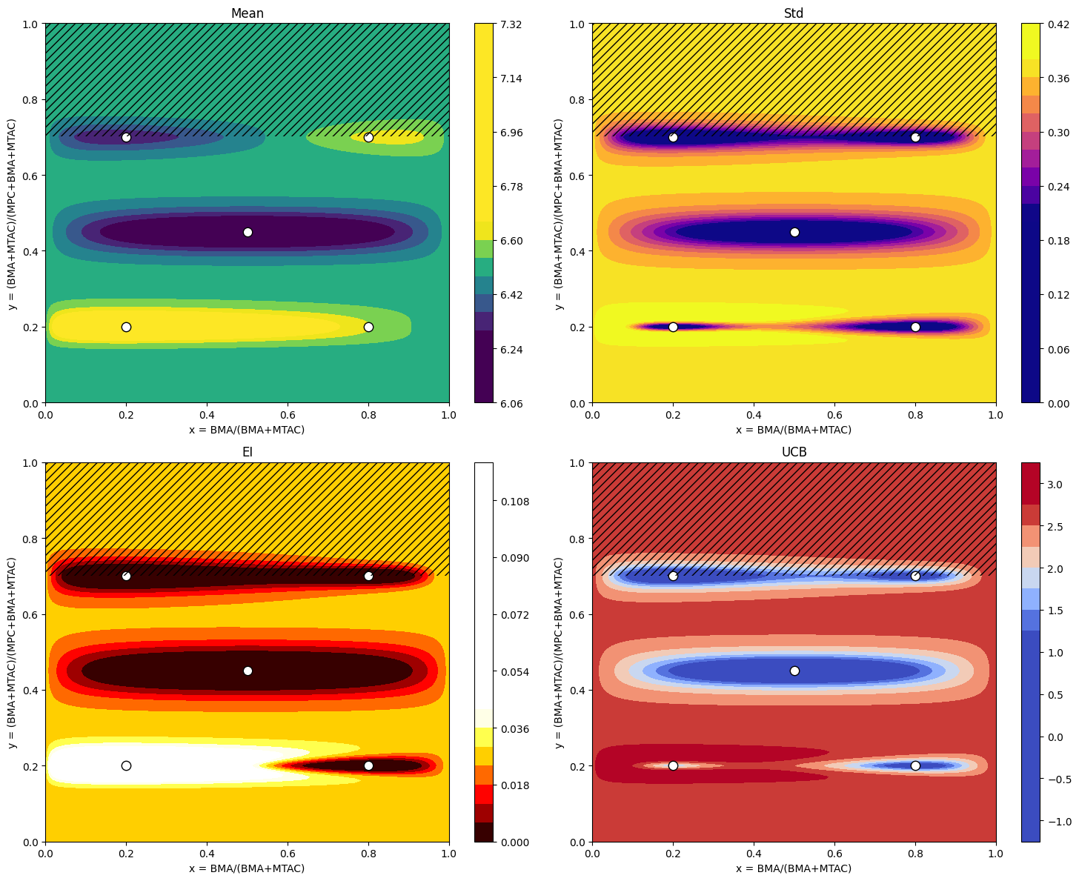
Figure 13. Bayesian Optimization Maps of Relative Activity (Mean, Std, EI, UCB; heat time = 20 min)

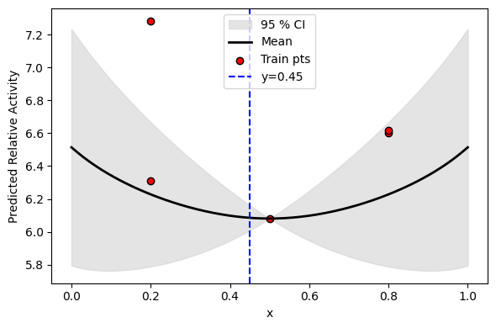
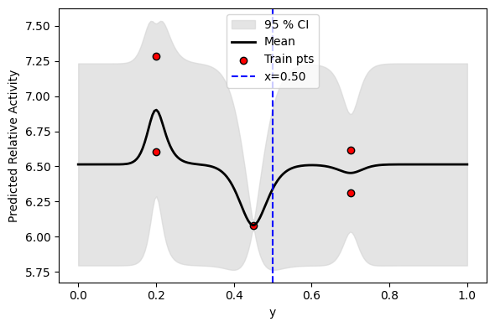

Figure 14. Predicted Relative Activity vs x (y = 0.45; 95% CI)”
Predicted Relative Activity vs y (x = 0.50; 95% CI)”

Common
• White circles = experimental points (training data).
• Hatched area = outside the search domain (y > 0.7 ≡ MPC < 30%).
• The color bar indicates the scale within each panel (for relative comparison).
1) Mean (top-left)
• Meaning: Gaussian-process predictive mean (Relative_Activity on the original scale).
• Interpretation: brighter colors mark regions expected to be better.
• In the map, along the y ≈ 0.2 band the areas near x ≈ 0.1 and x ≈ 0.85 are bright; a high-value island also appears at y ≈ 0.7 for large x.
→ Because the existing data lie on three y bands (y = 0.2 / 0.45 / 0.7), the map forms reliable “bands” along those lines.
2) Std (top-right)
• Meaning: predictive uncertainty (standard deviation).
• Interpretation: darker = more confident; brighter = more uncertain. It is dark near training points (around the white circles) and becomes brighter farther away.
→ This panel serves as a guide for exploration to acquire new information.
3) EI (bottom-left)
• Meaning: Expected Improvement (the expected gain beyond the current best).
• Interpretation: regions with a favorable balance of high mean × moderate uncertainty appear whitish.
→ In the map, x ≈ 0.1 at y ≈ 0.2 is the whitest, followed by y ≈ 0.2 with x ≈ 0.9, etc.
→ These are locations that are likely good yet still worth probing—prime candidates for the next measurements.
4) UCB (bottom-right)
• Meaning: Upper Confidence Bound = μ + κσ (here κ ≈ 2.6).
• Interpretation: regions with high mean and/or large σ appear brighter—an exploration-leaning criterion.
→ The upper band near y ≈ 0.7 with larger x is bright, highlighting promising possibilities even in sparsely sampled regions.

Cut plots (longitudinal / transverse sections)
x-cut (fixed y = 0.45)
• Black line = predictive mean; gray band = 95% CI; red dots = training points at that y.
• Values are higher near x ≈ 0.2 and x ≈ 0.8, with a mild valley around x ≈ 0.5.
→ This suggests that skewing the BMA:MTAC ratio away from the middle tends to perform better.
y-cut (fixed x = 0.50)
• The curve rises near y ≈ 0.2 and y ≈ 0.7 and dips around y ≈ 0.45.
→ The total (BMA + MTAC) fraction appears favorable at low/high ends but weaker in the middle, revealing nonlinearity—consistent with the “banded” appearance in the maps.

Next suggestion
1: x=0.125, y=0.190 | MPC= 81.0 %, MTAC= 16.6 %, BMA= 2.4 % | EI*=0.117
2: x=0.387, y=0.235 | MPC= 76.5 %, MTAC= 14.4 %, BMA= 9.1 % | EI*=0.000

- Future Plan
- Mastering Bayesian Optimization
  - Experimenting with Bayesian optimization in 3D space
- Determine whether to optimize using the GOx or Lip enzyme
- In the most recent experiment, we synthesized the composition proposed by Bayesian optimization to increase the information content.

Next action
- ポリマーと酵素のDLSを測定する。
- ポリマーの再合成を考える
- PMPC, PMTACのホモポリマーで酵素活性がどうなるかを検証する

- Appendix
Analyzed Tamasi et al’s data to determine the characteristics of copolymers that enhance heat resistance.
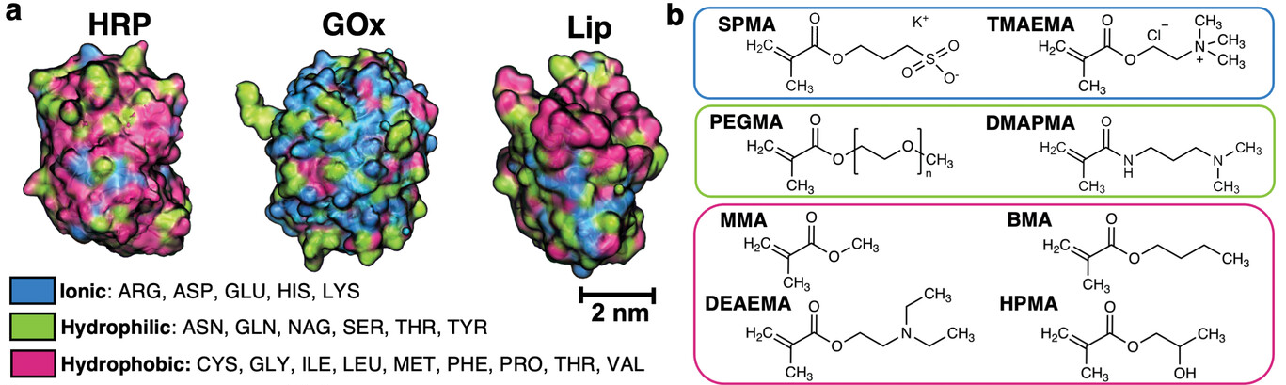
Table 8. Composition of the copolymer with the best performance
Enzyme | DP | SPMA | TMAEMA | PEGMA | DMAPMA | MMA | BMA | DEAEMA | HPMA | REA (%)
HRP | 75 | 0.17 | 0.24 | 0 | 0 | 0.55 | 0 | 0 | 0.04 | 81
GOx | 100 | 0.05 | 0 | 0.22 | 0.39 | 0 | 0.34 | 0 | 0 | 67.4
Lip | 125 | 0.32 | 0 | 0.25 | 0.31 | 0 | 0 | 0 | 0.12 | 108
Matthew J. Tamasi, Advanced Materials, 2022, 34, 30
After calculating molecular descriptors for each monomer using RDkit, we weighted them by the copolymer composition ratio to obtain the copolymer values.
We listed the meanings of the molecular descriptors used for each enzyme.
分子記述子 | 意味
MolLogP | オクタノール/水分配係数logP。大きいほど疎水性が強い
TPSA（Topological Polar Surface Area：極性表面積） | ヘテロ原子まわりの極性表面の総量。水和性・H結合能と相関。
NumHBA / NumHBD | H結合受容体の数。H結合供与体の数。
FractionCSP3（sp³炭素の比率：3D性/飽和度） | 値は 0（全て sp²）〜1（全て sp³）の間。骨格の“立体的なふくらみ”の指標（sp³が多い＝3D/柔らかい、少ない＝平面/硬い）。
Kier’s κ（Kappa1/2：形状・分岐・環の度合い） | 低くは 1（線状）に近い値から、高度に分岐する構造で大きく。分子トポロジーの“形の複雑さ/分岐”を表す無次元量。
Chi（例：Chi1v：原子価Chi） | 常に正の値で、構造が複雑になるほど大きく。結合パターンと原子価に基づく連結指数。分岐・置換度合いと相関。
HallKierAlpha | サイズ+分岐性に関連する位相量）

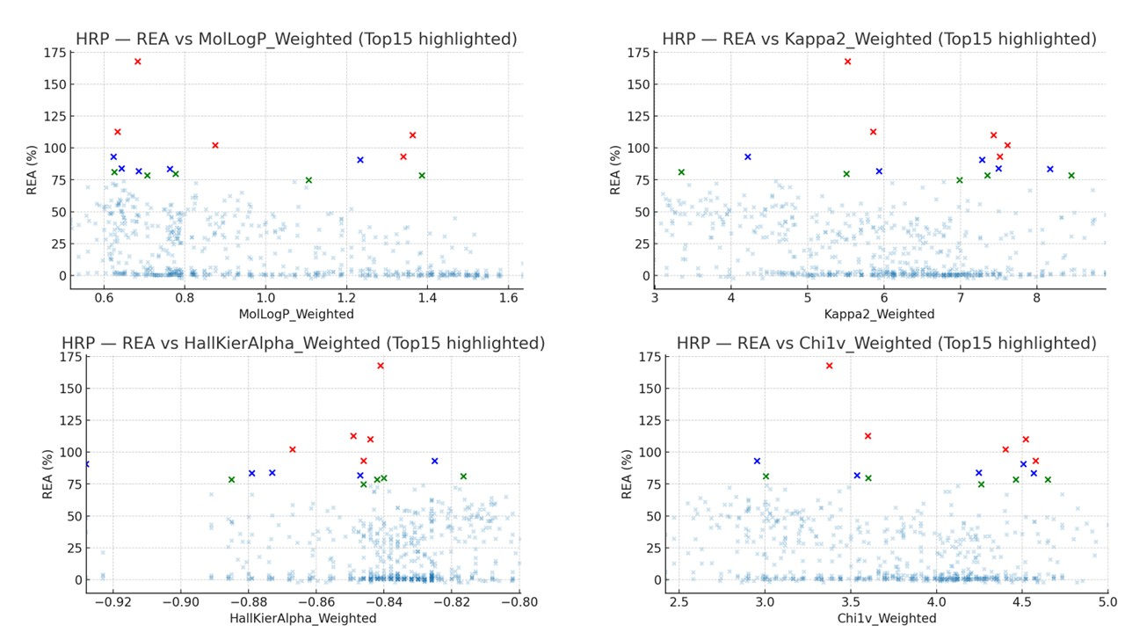
Figure 15. Top 15 highlighted copolymer for HRP
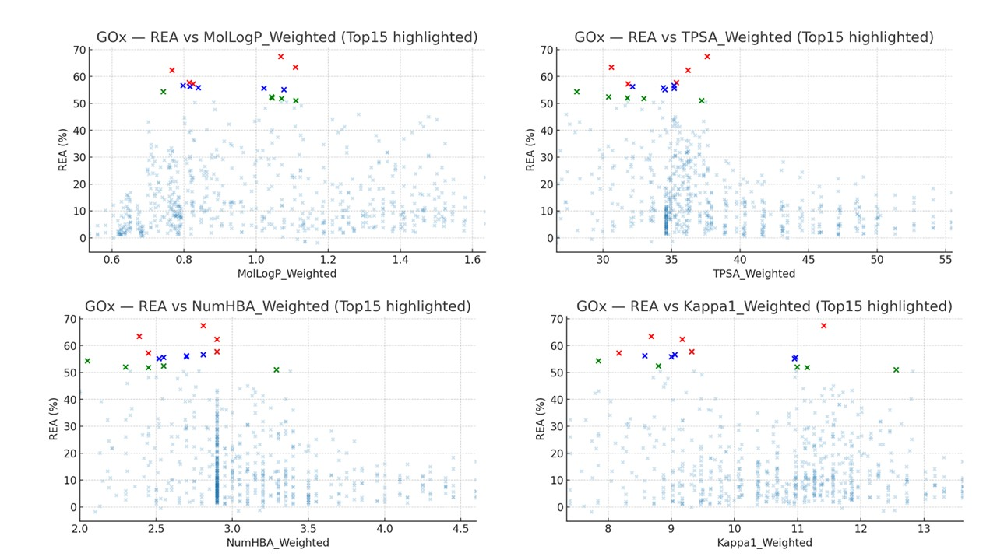
Figure 16. Top 15 highlighted copolymer for GOx
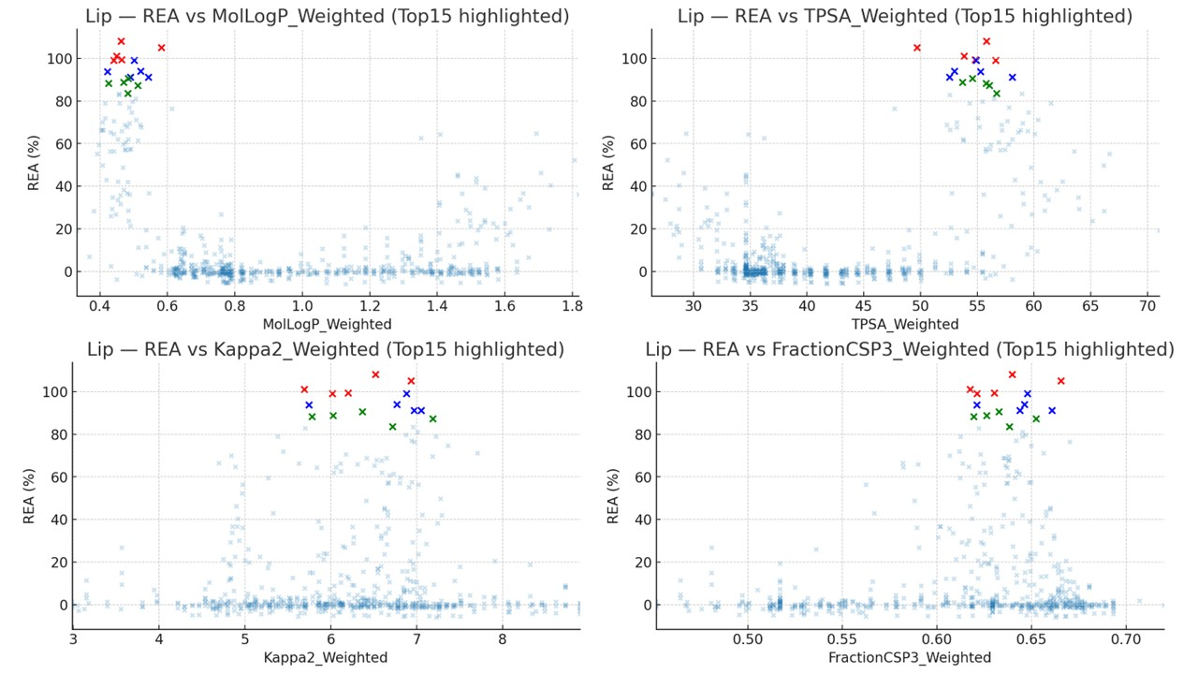
Figure 17. Top 15 highlighted copolymer for Lip

- One condition for a copolymer to enhance Lip's heat resistance is that it falls within the ranges defined by descriptors such as MolLogP, TPSA, Kappa2, and fractionCSP3.
- One approach is to limit the search to copolymer compositions that inherently fall within the ranges of these molecular descriptors.

